| **3.1. Мэдээлэл зүйн бодлого, алгоритмын чанар** |
| --- |

**Хуудас 100 (дасгал1)**

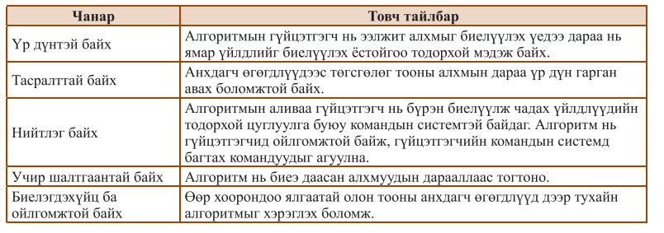

Үр дүнтэй байх - Анхдагч өгөгдлүүдээс төгсгөлөг тооны алхмын дараа үр дүн гарган авах боломжтой байх.

Тасралттай байх - Алгоритм нь биеэ даасан алхмуудын дарааллаас тогтоно.

Нийтлэг байх - Өөр хоорондоо ялгаатай олон тооны анхдагч өгөгдлүүд дээр тухайн | алгоритмыг хэрэглэх боломж.

Учир шалтгаантай байх - Алгоритмын гүйцэтгэгч нь ээлжит алхмыг биелүүлэх үедээ дараа нь ямар үйлдлийг биелүүлэх ёстойгоо тодорхой мэдэж байх

Биелэгдэхүйц ба ойлгомжтой байх - Алгоритмын аливаа гүйцэтгэгч нь бүрэн биелүүлж чадах үйлдлүүдийн тодорхой цуглуулга буюу командын системтэй байдаг. Алгоритм нь гүйцэтгэгчид ойлгомжтой байж, гүйцэтгэгчийн командын системд багтах командуудыг агуулна.

**Хуудас 100 (дасгал2)**

| a | b | c | p | s |
| --- | --- | --- | --- | --- |
| 3 | 3 | 3 | 4.5 | 3.89711 |
| 3 | 4 | 5 | 6 | 6 |
| 2 | 2 | 3 | 3.5 | 1.98431 |
| 5 | 7 | 8 | 10 | 17.3205 |

| x | Алгоритм үр дүн |
| --- | --- |
| 198 | Ondor |
| 165 | Namhan |
| 155 | Namhan |
| 148 | Namhan |

| N | Алгоритм үр дүн |
| --- | --- |
| 80 | B |
| 75 | B |
| 60 | D |
| 80 | B |
| 101 | A |
| 60 | D |
| 59 | D |
| 70 | C |

| nas | Алгоритм үр дүн |
| --- | --- |
| 8 | 3000 |
| 15 | 6000 |
| 12 | 6000 |
| 60 | 6000 |
| 48 | 6000 |
| 16 | 6000 |
| 21 | 6000 |
| 59 | 6000 |

| i | s |
| --- | --- |
| 2 | 2 |
| 4 | 6 |
| 6 | 12 |
| 8 | 20 |
| 10 | 30 |

| a=3, d=2, n=6 | i | ai = a+(i-1)*d; |
| --- | --- | --- |
| a=3, d=2, n=6 | 1 | 3 |
| a=3, d=2, n=6 | 2 | 5 |
| a=3, d=2, n=6 | 3 | 7 |
| a=3, d=2, n=6 | 4 | 9 |
| a=3, d=2, n=6 | 5 | 11 |
| a=3, d=2, n=6 | 6 | 13 |

**Хуудас 103 (дасгал1)**

GraphicsWindow.BackgroundColor = GraphicsWindow.GetColorFromRGB(255, 255, 255)

TextWindow.Write("'a': ")

a = TextWindow.Read()

TextWindow.Write("'b': ")

b = TextWindow.Read()

talbai = a * b

perimetr = (a + b) * 2

TextWindow.WriteLine("talbai: " + talbai)

TextWindow.WriteLine("Perimetr: " + perimetr)

**Хуудас 103 (дасгал2)**

**GraphicsWindow.BackgroundColor = GraphicsWindow.GetColorFromRGB(255, 255, 255)**

**TextWindow.Write("'r': ")**

**r = TextWindow.Read()**

**talbai = Math.Pi * (r * r)**

**TextWindow.WriteLine(talbai)**

**Хуудас 103 (дасгал3)**

GraphicsWindow.BackgroundColor = GraphicsWindow.GetColorFromRGB(255, 255, 255)

TextWindow.Write("x1 y1 x2 y2: ")

x1 = TextWindow.Read()

y1 = TextWindow.Read()

x2 = TextWindow.Read()

y2 = TextWindow.Read()

zai = Math.SquareRoot(Math.Power((x1 - x2), 2) + Math.Power((y1 - y2), 2))

TextWindow.WriteLine(zai)

**Хуудас 103 (дасгал4)**

GraphicsWindow.BackgroundColor = GraphicsWindow.GetColorFromRGB(255, 255, 255)

TextWindow.Write("a: ")

a = TextWindow.ReadNumber()

If a >= 0 Then

TextWindow.WriteLine("Eyreg too")

Else

TextWindow.WriteLine("Sorog too")

EndIf

**Хуудас 103 (дасгал5)**

GraphicsWindow.BackgroundColor = GraphicsWindow.GetColorFromRGB(255, 255, 255)

TextWindow.Write("2 toogoo oruul: ")

input = TextWindow.Read()

spaceIndex = Text.GetIndexOf(input, " ")

a = Text.GetSubText(input, 1, spaceIndex - 1)

b = Text.GetSubText(input, spaceIndex + 1, Text.GetLength(input) - spaceIndex)

a = TextWindow.ReadNumber()

b = TextWindow.ReadNumber()

If a = b Then

TextWindow.WriteLine("Tentsuu")

EndIf

If a > b Then

TextWindow.WriteLine(a)

Else

TextWindow.WriteLine(b)

EndIf

**Хуудас 103 (дасгал6)**

n = 3

a[1] = 0

a[2] = 0

a[3] = 0

For i = 1 To n

TextWindow.Write("a[" + i + "]: ")

a[i] = TextWindow.ReadNumber()

EndFor

max = a[1]

For i = 2 To n

If a[i] > max Then

max = a[i]

EndIf

EndFor

TextWindow.WriteLine("Max: " + max)

**Хуудас 103 (дасгал7)**

a = 0

b = 0

c = 0

TextWindow.Write("a: ")

a = TextWindow.ReadNumber()

TextWindow.Write("b: ")

b = TextWindow.ReadNumber()

TextWindow.Write("c: ")

c = TextWindow.ReadNumber()

If a = b And a = c And b = c Then

TextWindow.WriteLine("Zov gurvaljin")

ElseIf (a = b And b <> c) Or (a = c And c <> b) Or (b = c And c <> a) Then

TextWindow.WriteLine("Adil hajuut")

EndIf

**Хуудас 103 (дасгал8)**

GraphicsWindow.BrushColor = GraphicsWindow.GetColorFromRGB(255, 255, 255)

x1 = 0

y1 = 0

x2 = 0

y2 = 0

x3 = 0

y3 = 0

TextWindow.Write("x1, y1: ")

x1 = TextWindow.ReadNumber()

y1 = TextWindow.ReadNumber()

TextWindow.Write("x2, y2: ")

x2 = TextWindow.ReadNumber()

y2 = TextWindow.ReadNumber()

TextWindow.Write("x3, y3: ")

x3 = TextWindow.ReadNumber()

y3 = TextWindow.ReadNumber()

If ((x1 <> x2 Or y1 <> y2) And (x1 <> x3 Or y1 <> y3) And (x2 <> x3 Or y2 <> y3)) Then

If ((y2 - y1) * (x3 - x2) <> (y3 - y2) * (x2 - x1)) Then

TextWindow.WriteLine("Gurvaljjin Uusgene")

Else

TextWindow.WriteLine("Gurvaljin Uusgehgu")

EndIf

EndIf

**Хуудас 103 (дасгал9)**

k = 0

uld = 0

urj = 1

sum = 0

TextWindow.Write("K: ")

k = TextWindow.ReadNumber()

While k <> 0

uld = Math.Remainder(k,10)

urj = urj * uld

sum = sum + uld

k = Math.Floor(k / 10)

EndWhile

TextWindow.WriteLine(urj + " " + sum)

**Хуудас 103 (дасгал10)**

n = 0

uld = 0

tongor = 0

a = 0

TextWindow.Write("too: ")

n = TextWindow.ReadNumber()

a = n

While n <> 0

uld = Math.Remainder(n, 10)

tongor = tongor * 10 + uld

n = Math.Floor(n / 10)

EndWhile

If a = tongor Then

TextWindow.WriteLine("Palindrome too")

Else

TextWindow.WriteLine("Palindrome too bish")

EndIf

| **3.2 Програмчлалын small basic хэл, түүний элементүүд** |
| --- |

**1.**

TextWindow.WriteLine("B.Yesug")

TextWindow.WriteLine("Mongol Ulsiin Bolovsroliin Ih Surguuli")

TextWindow.WriteLine("MBUS Medeelel zuin tenhim")

**2.**

GraphicsWindow.BrushColor = GraphicsWindow.GetColorFromRGB(255, 255, 255)

GraphicsWindow.BrushColor = GraphicsWindow.GetColorFromRGB(0, 0, 255) ' Blue

GraphicsWindow.DrawText(10, 10, "Minii hayag")

GraphicsWindow.BrushColor = GraphicsWindow.GetColorFromRGB(255, 255, 0) ' Yellow

GraphicsWindow.DrawText(10, 30, "Manai angi")

GraphicsWindow.BrushColor = GraphicsWindow.GetColorFromRGB(0, 128, 0) ' Green

GraphicsWindow.DrawText(10, 50, "Ungu")

| **3.3 Хэмжигдэхүүн, өгөгдөл ба хувьсагч** |
| --- |

**Өөрийгөө сориорой**

**1.**



**s1= 113.4**

**S2 = 254.34**

**S3 = 706.5**

**S4 = 2640.74**

**s5= 5538.96**

**S6 = 24316.2**

**2.**

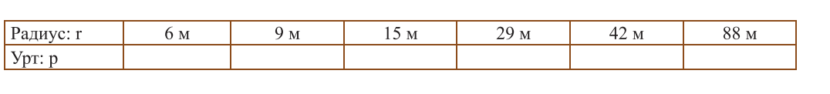

**p1= 37.68**

**P2= 56.52**

**p3= 94.2**

**p4= 182.12**

**p5= 263.76**

**p6= 552.64**

**3.**

| **a** | **b** | **c** | **SuuriS** | **HajuuSac** | **HajuuSbc** | **butenS** | **V** |
| --- | --- | --- | --- | --- | --- | --- | --- |
| **1** | **1** | **1** | **1** | **1** | **1** | **6** | **1** |
| **2** | **3** | **4** | **6** | **8** | **12** | **52** | **24** |
| **5** | **2** | **2** | **10** | **10** | **4** | **48** | **20** |
| **4** | **8** | **4** | **32** | **16** | **32** | **160** | **128** |
| **9** | **9** | **1** | **81** | **9** | **9** | **198** | **81** |
| **7** | **5** | **3** | **35** | **21** | **15** | **142** | **105** |
| **10** | **2** | **5** | **20** | **50** | **10** | **160** | **100** |

**4.**

| **a** | **b** | **c** | **p** | **s** |
| --- | --- | --- | --- | --- |
| **4** | **4** | **4** | **6** | **6.9282** |
| **5** | **3** | **4** | **6** | **6** |
| **10** | **8** | **5** | **11.5** | **19.81** |
| **5** | **5** | **6** | **8** | **12** |
| **7** | **8** | **14** | **14.5** | **18.7999** |

**5.**

| **Илэрхийлэл** | **Биелэх алхам, үр дүн** |
| --- | --- |
| **Жишээ оролт: a=3 b=3 c=3** | |
| **a+c-b*a^b+c*b^c** | **-713** |
| **a+b*c<=a*b+c&&c^b>b^a** |  |
| **(a+b)*c==c*c||a+b-c!=0*** |  |

**Даалгавар**

**1.**

GraphicsWindow.BrushColor = GraphicsWindow.GetColorFromRGB(255, 255, 255)

TextWindow.Write("a: ")

a = TextWindow.ReadNumber()

TextWindow.Write("b: ")

b = TextWindow.ReadNumber()

TextWindow.WriteLine("Urjver: " + a * b)

TextWindow.WriteLine("yalgavar: " + (a - b))

TextWindow.WriteLine("Nogdwor: " + (a / b))

**2.**

GraphicsWindow.BrushColor = GraphicsWindow.GetColorFromRGB(255, 255, 255)

TextWindow.Write("a: ")

a = TextWindow.ReadNumber()

s = a * a

p = (a + a) * 2

TextWindow.WriteLine(s + " " + p)

**3.**

GraphicsWindow.BrushColor = GraphicsWindow.GetColorFromRGB(255, 255, 255)

TextWindow.Write("a: ")

a = TextWindow.ReadNumber()

TextWindow.Write("b: ")

b = TextWindow.ReadNumber()

s = a * b

p = (a + b) * 2

TextWindow.WriteLine(s + " " + p)

**4.**

**Prism**

**5.**

**GraphicsWindow.BrushColor = GraphicsWindow.GetColorFromRGB(255, 255, 255)**

**TextWindow.Write("a: ")**

**a = TextWindow.ReadNumber()**

**TextWindow.Write("b: ")**

**b = TextWindow.ReadNumber()**

**TextWindow.Write("h: ")**

**h = TextWindow.ReadNumber()**

**vol = a * b * h**

**surf = 2 * a * b + 2 * b * h + 2 * a * h**

**TextWindow.WriteLine("Ezlehuun: " + vol)**

**TextWindow.WriteLine("Buten Gadarguun Talbai: " + surf)**

**6.**

**GraphicsWindow.BrushColor = GraphicsWindow.GetColorFromRGB(255, 255, 255)**

**TextWindow.Write("x1: ")**

**x1 = TextWindow.ReadNumber()**

**TextWindow.Write("y1: ")**

**y1 = TextWindow.ReadNumber()**

**TextWindow.Write("x2: ")**

**x2 = TextWindow.ReadNumber()**

**TextWindow.Write("y2: ")**

**y2 = TextWindow.ReadNumber()**

**zai = Math.SquareRoot((x1 - x2) * (x1 - x2) + (y1 - y2) * (y1 - y2))**

**TextWindow.WriteLine("Zai: " + zai)**

**7.**

**GraphicsWindow.BrushColor = GraphicsWindow.GetColorFromRGB(255, 255, 255)**

**TextWindow.Write("a: ")**

**a = TextWindow.ReadNumber()**

**TextWindow.Write("b: ")**

**b = TextWindow.ReadNumber()**

**c = Math.SquareRoot(a * a + b * b)**

**TextWindow.WriteLine((a * b) / 2 + a + b + c)**

**8.**

**GraphicsWindow.BackgroundColor = GraphicsWindow.GetColorFromRGB(255, 255, 255)**

**TextWindow.Write("'r': ")**

**r = TextWindow.Read()**

**talbai = Math.Pi * (r * r)**

**TextWindow.WriteLine(talbai)**

| **3.4 Салаалалт** |
| --- |

**1.**

| **x** | **Үр дүн** |
| --- | --- |
| **198** | **Undur** |
| **165** | **Dundaj** |
| **155** | **Dundaj** |
| **149** | **Namhan** |

**2.**

| nas | Хураамж |
| --- | --- |
| 8 | 3000 |
| 12 | 6000 |
| 17 | 6000 |
| 20 | 6000 |
| 30 | 6000 |
| 60 | 6000 |
| 65 | 2000 |

**3.**

| N | Үсгэн дүн |
| --- | --- |
| 100 | A |
| 69.9 | D |
| 70 | D |
| 80 | C |
| 79.8 | C |
| 60 | D |
| 61 | D |
| 81 | B |
| 59.9 | D |
| 71 | C |

**Даалгавар**

**1.**

**TextWindow.Write("a too oruul: ")**

**a = TextWindow.ReadNumber()**

**TextWindow.Write("b too oruul: ")**

**b = TextWindow.ReadNumber()**

**TextWindow.Write("c too oruul: ")**

**c = TextWindow.ReadNumber()**

**min = a**

**If (a+b>c) And (a+c>b) And (b+c>a) Then**

**TextWindow.ForegroundColor = "Green"**

**TextWindow.WriteLine(a + ", " + b + ", " + c + "talbai gurvaljin orshin baina")**

**Else**

**TextWindow.ForegroundColor = "Red"**

**TextWindow.WriteLine(a + ", " + b + ", " + c + "talbai gurvaljin orshin baihgu")**

**Endif**

2 2 3 -> talbai gurvaljin orshin baina

1 2 3-> 1, 2, 3talbai gurvaljin orshin baihgu

5 5 8-> 5, 5, 8talbai gurvaljin orshin baina

3 4 7-> 3, 4, 7talbai gurvaljin orshin baihgu

**2.**

GraphicsWindow.BackgroundColor = GraphicsWindow.GetColorFromRGB(255, 255, 255)

TextWindow.Write("a: ")

a = TextWindow.ReadNumber()

If a >= 0 Then

TextWindow.WriteLine("Eyreg too")

Else

TextWindow.WriteLine("Sorog too")

EndIf

**3.**

GraphicsWindow.BackgroundColor = GraphicsWindow.GetColorFromRGB(255, 255, 255)

TextWindow.Write("2 toogoo oruul: ")

input = TextWindow.Read()

spaceIndex = Text.GetIndexOf(input, " ")

a = Text.GetSubText(input, 1, spaceIndex - 1)

b = Text.GetSubText(input, spaceIndex + 1, Text.GetLength(input) - spaceIndex)

a = TextWindow.ReadNumber()

b = TextWindow.ReadNumber()

If a = b Then

TextWindow.WriteLine("Tentsuu")

EndIf

If a > b Then

TextWindow.WriteLine(a)

Else

TextWindow.WriteLine(b)

EndIf

**4.**

n = 3

a[1] = 0

a[2] = 0

a[3] = 0

For i = 1 To n

TextWindow.Write("a[" + i + "]: ")

a[i] = TextWindow.ReadNumber()

EndFor

max = a[1]

For i = 2 To n

If a[i] > max Then

max = a[i]

EndIf

EndFor

**5.**

a = 0

b = 0

c = 0

TextWindow.Write("a: ")

a = TextWindow.ReadNumber()

TextWindow.Write("b: ")

b = TextWindow.ReadNumber()

TextWindow.Write("c: ")

c = TextWindow.ReadNumber()

If a = b And a = c And b = c Then

TextWindow.WriteLine("Zov gurvaljin")

ElseIf (a = b And b <> c) Or (a = c And c <> b) Or (b = c And c <> a) Then

TextWindow.WriteLine("Adil hajuut")

EndIf

**6.**

x1 = 0

y1 = 0

x2 = 0

y2 = 0

x3 = 0

y3 = 0

TextWindow.Write("x1, y1: ")

x1 = TextWindow.ReadNumber()

y1 = TextWindow.ReadNumber()

TextWindow.Write("x2, y2: ")

x2 = TextWindow.ReadNumber()

y2 = TextWindow.ReadNumber()

TextWindow.Write("x3, y3: ")

x3 = TextWindow.ReadNumber()

y3 = TextWindow.ReadNumber()

If ((x1 <> x2 Or y1 <> y2) And (x1 <> x3 Or y1 <> y3) And (x2 <> x3 Or y2 <> y3)) Then

If ((y2 - y1) * (x3 - x2) <> (y3 - y2) * (x2 - x1)) Then

TextWindow.WriteLine("Orshin baina")

Else

TextWindow.WriteLine("Ugui")

EndIf

EndIf

**7.**

**GraphicsWindow.BackgroundColor = GraphicsWindow.GetColorFromRGB(255, 255, 255)**

**TextWindow.Write("Ongo red, green, blue): ")**

**colorInput = TextWindow.Read()**

**GraphicsWindow.Clear()**

**If colorInput = "red" Then**

**TextWindow.ForegroundColor = "Red"**

**TextWindow.WriteLine("Ulaan")**

**ElseIf colorInput = "green" Then**

**TextWindow.ForegroundColor = "Green"**

**TextWindow.WriteLine("Nogoon")**

**ElseIf colorInput = "blue" Then**

**TextWindow.ForegroundColor = "Blue"**

**TextWindow.WriteLine("Tsenher")**

**EndIf**

**8.**

**GraphicsWindow.BackgroundColor = GraphicsWindow.GetColorFromRGB(255, 255, 255)**

**TextWindow.Write("a: ")**

**a = TextWindow.ReadNumber()**

**TextWindow.Write("b: ")**

**b = TextWindow.ReadNumber()**

**TextWindow.Write("c: ")**

**c = TextWindow.ReadNumber()**

**D = b * b - 4 * a * c**

**If D < 0 Then**

**TextWindow.WriteLine("Bodit shiidgu.")**

**ElseIf D = 0 Then**

**root = -b / (2 * a)**

**TextWindow.WriteLine("Gants shiidtei: " + root)**

**Else**

**root1 = (-b + Math.SquareRoot(D)) / (2 * a)**

**root2 = (-b - Math.SquareRoot(D)) / (2 * a)**

**TextWindow.WriteLine("x1: " + root1)**

**TextWindow.WriteLine("x2: " + root2)**

**EndIf**

**9.**

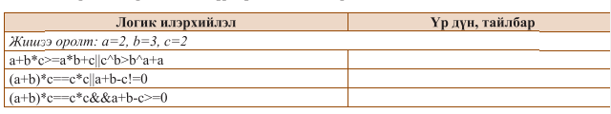

| **3.5 Давталт** |
| --- |

**Өөрийгөө сориорой**

**1.**

| **n** | **s** |
| --- | --- |
| **5** | **6** |
| **8** | **20** |
| **10** | **30** |
| **55** | **756** |
| **102** | **2652** |

**2.**

| **a** | **d** | **n** | **ai** |
| --- | --- | --- | --- |
| **1** | **2** | **10** | **1 3 5 7 9 11 13 15 17 19** |
| **2** | **1** | **12** | **2 3 4 5 6 7 8 9 10 11 12 13** |
| **10** | **4** | **8** | **10 14 18 22 26 30 34 38** |
| **15** | **5** | **5** | **15 20 25 30 35** |
| **19** | **3** | **6** | **19 22 25 28 31 34** |

**3.**

| **a** | **d** | **n** | **s** |
| --- | --- | --- | --- |
| **1** | **2** | **10** | **100** |
| **2** | **1** | **12** | **190** |
| **10** | **4** | **8** | **382** |
| **15** | **5** | **5** | **507** |
| **19** | **3** | **6** | **19 22 25 28 31 34** |

**Даалгавар**

**1.**

| **n=100** | **n=200** | **n=500** | **n=1000** |
| --- | --- | --- | --- |
| **Niilber: 1050** | **Niilber: 5150** | **Niilber:30400** | **Niilber: 130900** |

**2.**

**Ном дээр 2-р бодлого алга**

**3.**

**GraphicsWindow.BrushColor = GraphicsWindow.GetColorFromRGB(255, 255, 255)**

**TextWindow.Write("n: ")**

**n = TextWindow.ReadNumber()**

**sum = 0**

**For i = 1 To n**

**sum = sum + i**

**EndFor**

**TextWindow.WriteLine(sum)**

**4.**

**GraphicsWindow.BrushColor = GraphicsWindow.GetColorFromRGB(255, 255, 255)**

**TextWindow.Write("n: ")**

**n = TextWindow.ReadNumber()**

**TextWindow.Write("k: ")**

**k = TextWindow.ReadNumber()**

**TextWindow.WriteLine("1-n hurtelh sondgoi toonuud: ")**

**For i = 1 To n Step 2**

**TextWindow.Write(i + " ")**

**EndFor**

**sum = 0**

**TextWindow.WriteLine("1-n hurtelh niilber: ")**

**For i = 2 To n Step 2**

**sum = sum + i**

**EndFor**

**TextWindow.WriteLine(sum)**

**urj = 1**

**TextWindow.WriteLine("1- n k toond huvaagdaj baiwal urj: ")**

**For i = 1 To n**

**If Math.Remainder(i,k) = 0 Then**

**urj = urj * i**

**EndIf**

**EndFor**

**TextWindow.WriteLine(urj)**

**5.**

GraphicsWindow.BrushColor = GraphicsWindow.GetColorFromRGB(255, 255, 255)

TextWindow.Write("n: ")

n = TextWindow.ReadNumber()

For i = n To 0 Step -1

TextWindow.Write(i + " ")

EndFor

**6.**

n = 0

uld = 0

tongor = 0

a = 0

TextWindow.Write("too: ")

n = TextWindow.ReadNumber()

a = n

While n <> 0

uld = Math.Remainder(n, 10)

tongor = tongor * 10 + uld

n = Math.Floor(n / 10)

EndWhile

If a = tongor Then

TextWindow.WriteLine("Palindrome too")

Else

TextWindow.WriteLine("Palindrome too bish")

EndIf

**7.**

**GraphicsWindow.BackgroundColor = GraphicsWindow.GetColorFromRGB(255, 255, 255)**

**TextWindow.Write("n: ")**

**n = TextWindow.ReadNumber()**

**TextWindow.Write("k: ")**

**k = TextWindow.ReadNumber()**

**count = 0**

**number = 1**

**While count < n**

**tsifr = 0**

**halaas = number**

**While halaas > 0**

**tsifr = tsifr + Math.Remainder(halaas, 10)**

**halaas = Math.Floor(halaas / 10)**

**EndWhile**

**If tsifr = k Then**

**TextWindow.Write(number + " ")**

**count = count + 1**

**EndIf**

**number = number + 1**

**EndWhile**

**8.**

**TextWindow.Write("n: ")**

**n = TextWindow.ReadNumber()**

**TextWindow.Write("k: ")**

**k = TextWindow.ReadNumber()**

**TextWindow.Write("t: ")**

**t = TextWindow.ReadNumber()**

**For i = 1 To n**

**If Math.Remainder(i, k) = 0 Then**

**TextWindow.Write(i + " ")**

**EndIf**

**EndFor**

**TextWindow.WriteLine("")**

**For i = 1 To n**

**If Math.Remainder(i, 10) = t Then**

**TextWindow.Write(i + " ")**

**EndIf**

**EndFor**

| **3.6 График боловсруулалт** |
| --- |

**Өөрийгөө сориорой**

**1.**

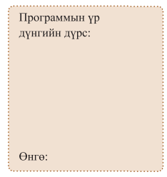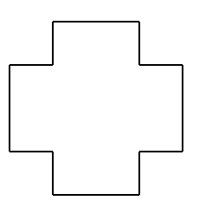

**2.**

**x = TextWindow.ReadNumber()**

**y = TextWindow.ReadNumber()**

**a = TextWindow.ReadNumber()**

**GraphicsWindow.PenColor = "Dark Green"**

**GraphicsWindow.DrawTriangle(x, y, x+a, y, x, y+a)**



**Даалгавар**

**1.**

**GraphicsWindow.BackgroundColor = GraphicsWindow.GetColorFromRGB(255, 255, 255)**

**GraphicsWindow.PenColor = "Blue"**

**GraphicsWindow.DrawEllipse(50, 50, 100, 100)**

**GraphicsWindow.PenColor = "Yellow"**

**GraphicsWindow.DrawEllipse(150, 50, 100, 100)**

**GraphicsWindow.PenColor = "Black"**

**GraphicsWindow.DrawEllipse(250, 50, 100, 100)**

**GraphicsWindow.PenColor = "Green"**

**GraphicsWindow.DrawEllipse(100, 100, 100, 100)**

**GraphicsWindow.PenColor = "Red"**

**GraphicsWindow.DrawEllipse(200, 100, 100, 100)**

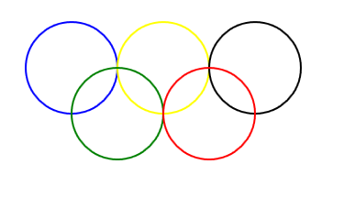

**2.**

**star=145**

**GraphicsWindow.BackgroundColor="White"**

**Turtle.Speed=10**

**Turtle.move (100)**

**Turtle.Turn (star)**

**Turtle.Move (100)**

**Turtle.Turn (star)**

**Turtle.Move (100)**

**Turtle.Turn (star)**

**Turtle.Move (100)**

**Turtle.Turn (star)**

**Turtle.move (100)**

**Turtle.Turn (star)**

**3.**

**GraphicsWindow.BackgroundColor = "White"**

**GraphicsWindow.DrawRectangle(50, 50, 100, 100)**

**GraphicsWindow.BrushColor = "Red"**

**GraphicsWindow.FillRectangle(50, 50, 100, 100)**

**—---------------------------------------------**

**GraphicsWindow.BackgroundColor = "White"**

**GraphicsWindow.DrawRectangle(50, 50, 300, 100)**

**GraphicsWindow.BrushColor = "Green"**

**GraphicsWindow.FillRectangle(50, 50, 300, 100)**

**GraphicsWindow.PenColor = "Blue"**

**GraphicsWindow.DrawRectangle(50, 50, 300, 100)**

**—-----------------------------------------------**

**GraphicsWindow.BackgroundColor = "White"**

**red = Math.GetRandomNumber(256)**

**green = Math.GetRandomNumber(256)**

**blue = Math.GetRandomNumber(256)**

**color = GraphicsWindow.GetColorFromRGB(red, green, blue)**

**GraphicsWindow.DrawEllipse(100, 100, 200, 100)**

**GraphicsWindow.BrushColor = color**

**GraphicsWindow.FillEllipse(100, 100, 200, 100)**

**—------------------------------------------------**

**4.**

**GraphicsWindow.BackgroundColor = "White"**

**GraphicsWindow.DrawTriangle(200, 100, 300, 200, 200, 300)**

**GraphicsWindow.DrawLine(200, 100, 100, 200)**

**GraphicsWindow.DrawLine(200, 100, 200, 300)**

**GraphicsWindow.DrawLine(300, 200, 200, 300)**

**GraphicsWindow.DrawLine(100, 200, 200, 300)**

**—---------------------------------------------------**

**GraphicsWindow.BackgroundColor = "White"**

**GraphicsWindow.BrushColor = "LightBlue"**

**houseBodyWidth = 200**

**houseBodyHeight = 120**

**houseBodyX = 200**

**houseBodyY = 200**

**GraphicsWindow.FillRectangle(houseBodyX, houseBodyY, houseBodyWidth, houseBodyHeight)**

**roofWidth = houseBodyWidth + 40**

**roofHeight = 100**

**roofX = houseBodyX - (roofWidth - houseBodyWidth) / 2**

**roofY = houseBodyY - roofHeight**

**GraphicsWindow.FillTriangle(roofX, roofY + roofHeight, roofX + roofWidth / 2, roofY, roofX + roofWidth, roofY + roofHeight)**

**chimneyWidth = 20**

**chimneyHeight = 50**

**chimneyX = roofX + (roofWidth / 2 + 10)**

**chimneyY = roofY - (chimneyHeight - 20)**

**GraphicsWindow.FillRectangle(chimneyX, chimneyY, chimneyWidth, chimneyHeight)**

**doorWidth = 40**

**doorHeight = 60**

**doorX = houseBodyX + (houseBodyWidth / 2 - doorWidth / 2)**

**doorY = houseBodyY + (houseBodyHeight - doorHeight)**

**GraphicsWindow.BrushColor = "DarkBlue"**

**GraphicsWindow.FillRectangle(doorX, doorY, doorWidth, doorHeight)**

**windowWidth = 30**

**windowHeight = 30**

**windowX1 = houseBodyX + (doorX - houseBodyX) / 2 - windowWidth / 2**

**windowY = doorY - (doorY - houseBodyY) / 2 - windowHeight / 2**

**windowX2 = doorX + doorWidth + (doorX - houseBodyX) / 2 - windowWidth / 2**

**GraphicsWindow.BrushColor = "LightBlue"**

**GraphicsWindow.FillRectangle(windowX1, windowY, windowWidth, windowHeight)**

**GraphicsWindow.FillRectangle(windowX2, windowY, windowWidth, windowHeight)**

**5.**

**3.7 Давталт ба график**

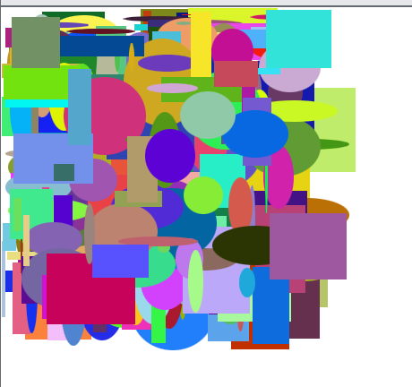

**—-------------------------------------------------**

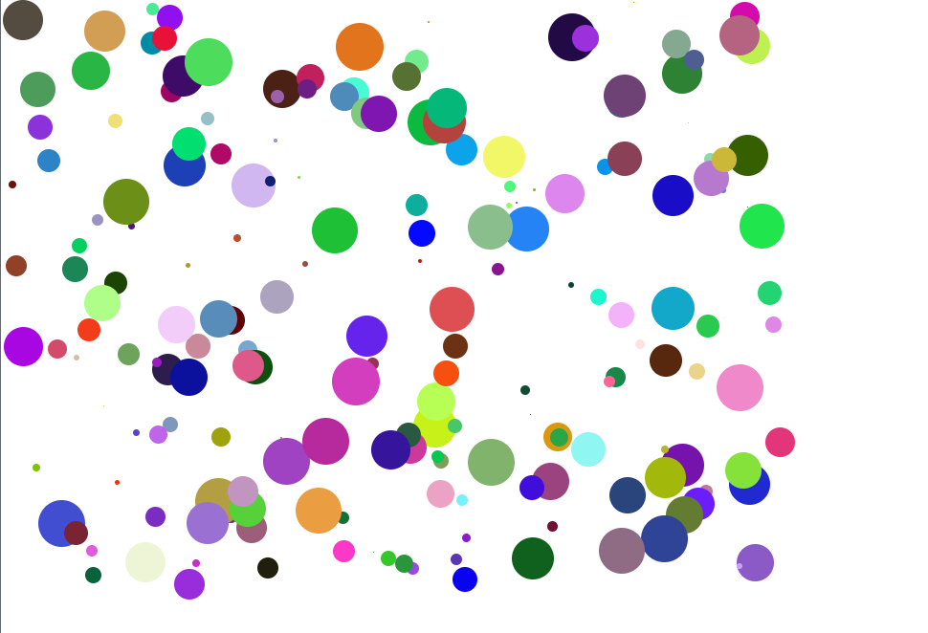

—------------------------------------------------------

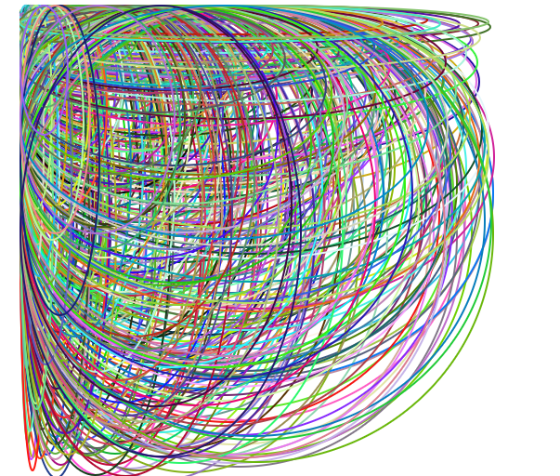

3.

GraphicsWindow.Width = 310: Энэ команд нь график цонхны өргөнийг 310 нэгж болгож тохируулна.

GraphicsWindow.Height = 310: Энэ команд нь график цонхны өндрийг 310 нэгж болгож тохируулна.

GraphicsWindow.PenWidth = 5: Энэ команд нь дүрс эсвэл шугам зурахад ашигладаг үзэг эсвэл зураасны өргөнийг 5 нэгж болгон тохируулна.

4.



5.

GraphicsWindow.Width = 300

GraphicsWindow.Height = 400

For i = 1 To 1000

x = Math.GetRandomNumber(GraphicsWindow.Width)

y = Math.GetRandomNumber(GraphicsWindow.Height)

GraphicsWindow.DrawEllipse(x, y, 1, 1)

EndFor

6.

GraphicsWindow.BackgroundColor = GraphicsWindow.GetColorFromRGB(255, 255, 255) '

width = 400

height = 400

numRectangles = 200

For i = 1 To numRectangles

x = Math.GetRandomNumber(width)

y = Math.GetRandomNumber(height)

rectWidth = Math.GetRandomNumber(50)

rectHeight = Math.GetRandomNumber(50)

color = GraphicsWindow.GetColorFromRGB(Math.GetRandomNumber(256), Math.GetRandomNumber(256), Math.GetRandomNumber(256))

GraphicsWindow.DrawRectangle(x, y, rectWidth, rectHeight)

GraphicsWindow.SetPixel(x, y, color)

EndFor

7.

GraphicsWindow.BackgroundColor = GraphicsWindow.GetColorFromRGB(255, 255, 255)

width = 400

height = 400

numTriangles = 200

For i = 1 To numTriangles

x1 = Math.GetRandomNumber(width)

y1 = Math.GetRandomNumber(height)

x2 = Math.GetRandomNumber(width)

y2 = Math.GetRandomNumber(height)

x3 = Math.GetRandomNumber(width)

y3 = Math.GetRandomNumber(height)

color = GraphicsWindow.GetColorFromRGB(Math.GetRandomNumber(256), Math.GetRandomNumber(256), Math.GetRandomNumber(256))

GraphicsWindow.DrawTriangle(x1, y1, x2, y2, x3, y3)

GraphicsWindow.SetPixel(x1, y1, color)

GraphicsWindow.SetPixel(x2, y2, color)

GraphicsWindow.SetPixel(x3, y3, color)

EndFor

8.

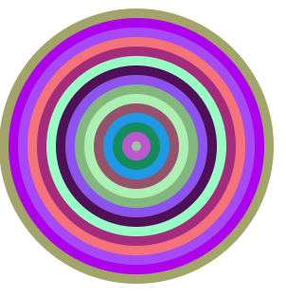

9.

3.8 Яст мэлхийн график

1.

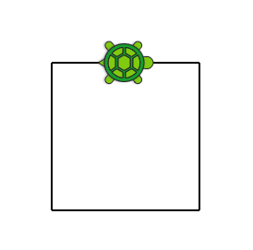

2. 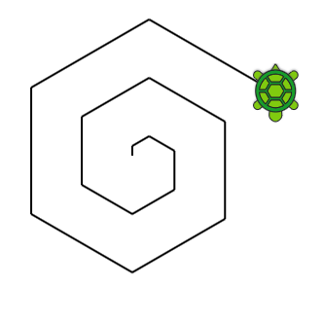

3.

n = TextWindow.ReadNumber()

k = TextWindow.ReadNumber()

s = 0

For i = 1 To n

t = Math.GetRandomNumber(100)

u = Math.Remainder(t, k)

If u=0 Then

s = s+t

TextWindow.Write(" "+t +" ")

EndIf

EndFor

TextWindow.WriteLine("")

TextWindow.WriteLine("Niilber: "+s)

4.

n = TextWindow.ReadNumber()

k = TextWindow.ReadNumber()

s = 0

For i = 1 To n

t = Math.GetRandomNumber(100)

u = Math.Remainder(t, k)

If u=0 Then

s = s+t

TextWindow.Write(" "+t +" ")

EndIf

EndFor

TextWindow.WriteLine("")

TextWindow.WriteLine("Niilber: "+s)

n = TextWindow.ReadNumber()

For i=1 To n

t = Math.GetRandomNumber(10000)

q = Math.SquareRoot(t)

If q=Math.Floor(q) Then

TextWindow.WriteLine(t+" too "+q+"toony quadrat bolj")

EndIf

EndFor

3.9 Математик объектын функц, шинж чанарууд

Өөрийгөө сориорой

1.

a = Math.GetRandomNumber(100)

b = Math.GetRandomNumber(100)

If a>b Then

t = a

a = b

t = b

EndIf

TextWindow.Write(a+" ")

TextWindow.WriteLine(b+” ”)

Санамсаргүй тоо 100 дотор сонгоод их болон багын байрыг нь сольдог программ байнаа

2.

a = Math.GetRandomNumber(100)

b = Math.GetRandomNumber(100)

If a>b Then

t = a

a = b

t = b

EndIf

For i = a To b

u = Math.Remainder(i, 5)

If u=0 Then

s = Math.Power(i,2)

TextWindow.WriteLine(s)

EndIf

EndFor

2.

GraphicsWindow.MouseX: График цонхон дээрх хулганы курсорын X координатыг илэрхийлнэ.

GraphicsWindow.MouseY: График цонхон дээрх хулганы курсорын Y координатыг илэрхийлнэ.

GraphicsWindow.FontBold: Үсгийн фонт тод байх эсэхийг заана.

GraphicsWindow.FontItalic: Фонт налуу байх эсэхийг заана.

GraphicsWindow.FontName: График цонхны текстэнд ашигласан фонтын нэрийг илэрхийлнэ.

GraphicsWindow.FontSize: График цонхны текстэнд ашигласан үсгийн хэмжээг илэрхийлнэ.

SetPixel(x, y, c): Заасан координат (x, y) дээрх пикселийн өнгийг заасан өнгө болгон тохируулна c.

ShowMessage(tx1, tx2): Гарчгийн талбарт tx1, агуулгын талбарт tx2 заасан бичвэр бүхий мессежийн хайрцгийг харуулна.

DrawText(x, y, txt): График цонхон дээр заасан координатууд (x, y) дээр текстийг өгөгдсөн txt текстээр зурна.

2.

a.

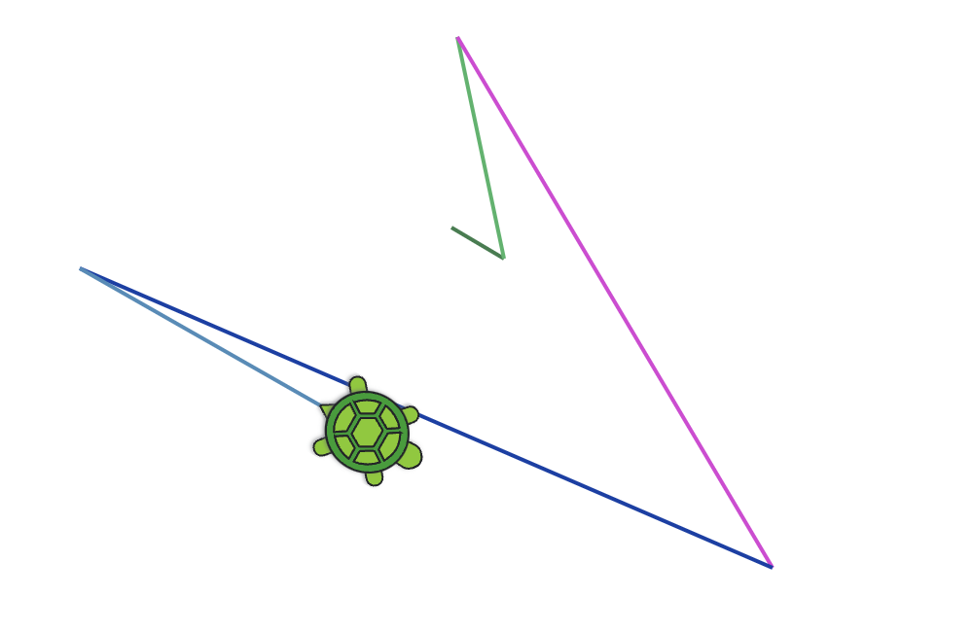

B.

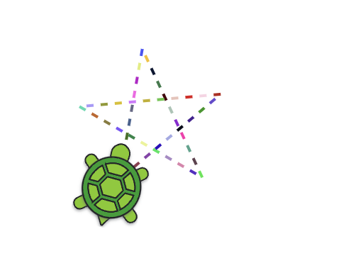

Даалгавар

1.

a = TextWindow.ReadNumber("a: ")

b = TextWindow.ReadNumber("b: ")

c = TextWindow.ReadNumber("c: ")

d = TextWindow.ReadNumber("d: ")

e = TextWindow.ReadNumber("e: ")

min = a

If b < min Then

min = b

EndIf

If c < min Then

min = c

EndIf

If d < min Then

min = d

EndIf

If e < min Then

min = e

EndIf

TextWindow.WriteLine("min: " + min)

3.

n = TextWindow.ReadNumber("too: ")

For i = 1 To n

randomNumber = Math.GetRandomNumber(100) TextWindow.WriteLine("Random Number " + i + ": " + randomNumber)

lnValue = Math.Log(randomNumber)

log10Value = Math.Log10(randomNumber)

TextWindow.WriteLine("ln(" + randomNumber + "): " + lnValue)

TextWindow.WriteLine("log10(" + randomNumber + "): " + log10Value)

TextWindow.WriteLine()

EndFor

4.

randomNumber = Math.GetRandomNumber(100)

TextWindow.WriteLine("Random Number: " + randomNumber)

sqrtValue = Math.SquareRoot(randomNumber)

TextWindow.WriteLine("Square Root of " + randomNumber + ": " + sqrtValue)

5.

n = TextWindow.ReadNumber("n: ")

m = TextWindow.ReadNumber("m: ")

m = TextWindow.ReadNumber("k: ")

powerByM = Math.Power(n, m) ' Calculate the power of random number by n

powerByK = Math.Power(n, k)

Text.WindowWriteLine(powerByM,powerByK)

6.

GraphicsWindow.BackgroundColor = "White"

GraphicsWindow.DrawRectangle(0, 0, GraphicsWindow.Width, GraphicsWindow.Height)

scaleX = 30

scaleY = 50

step = 0.1

For x = -10 To 10 Step step

y1 = Math.Sin(x) * scaleY + GraphicsWindow.Height / 2

y2 = Math.Cos(x) * scaleY + GraphicsWindow.Height / 2

GraphicsWindow.SetPixel(x * scaleX + GraphicsWindow.Width / 2, y1, "Blue")

GraphicsWindow.SetPixel(x * scaleX + GraphicsWindow.Width / 2, y2, "Red")

EndFor

Өөрийгөө сориорой

1.в

2.в

3.г

4.в

5.г

6.в

7.

**TextWindow**:

Write()

Read()

ReadNumber()

WriteLine()

GraphicsWindow:

DrawEllipse()

FillRectangle()

DrawText()

GetRandomColor()

**Turtle:**

MoveTo()

Turn()

PenDown()

DrawTriangle()

**Math**:

Remainder()

Power()

Max()

Min()

8.

TextWindow: ForeGroundColor

GraphicsWindow: PenColor, Height, PenWidth, Width, BrushColor

Turtle: Speed, Angle

Math: PI

9.б

10.в

11.в

12.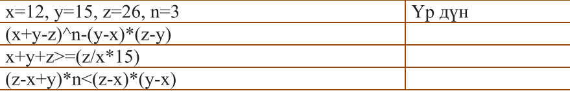

-32,true,false

13. 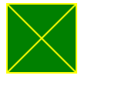

14.г

15.б

16.б

17.г

18.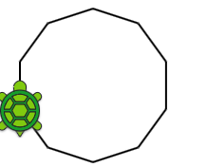

19.в

20.в

21.GraphicsWindow.GetRandomColor(): Үзэгний өнгийг санамсаргүй өнгө болгон тохируулна.

GraphicsWindow.BrushColor = GraphicsWindow.PenColor(): Сойзны өнгийг үзэгний өнгөтэй ижил өнгөтэй болгоно.

GraphicsWindow.FillTriangle(10, 10, 50, 10, 10, 50): (10, 10), (50, 10) болон (10, 50) оройтой дүүргэсэн гурвалжинг зурна.

GraphicsWindow.DrawText(100, 100, "Гурвалжин"): График цонхны координат (100, 100) дээр "Гурвалжин" текстийг бичнэ.

22.а

23.б

24.а

25.б

26.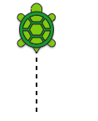

27.а

28.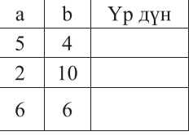

Үр дүн: 9,5,36

29.

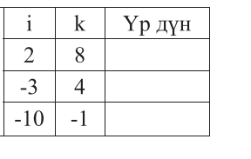

Үр дүн: 203,44,385

30.

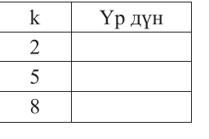

Үр дүн: , ’,